John Incantalupo

CSC-485 Capstone

Dr. Chou

March 8, 2024

Project #1

Data Overview

Providing equal and proficient education for students of all backgrounds has always been a struggle, especially in the United States. It is no secret that the average test scores for various college placement exams, such as the SATs, have been steadily dropping for decades. The United States has attempted to counteract this by putting more financial resources into education. In Figure 2, we see that beginning in 2012, the amount of educational spending per pupil across the country skyrocketed, yet Figure 1 suggests that these efforts are all in vain, as scores continue to plummet. So, I have decided to examine both funding data and test score data from each U.S. state to look for answers that explain this phenomenon. I plan to look into the interaction between the amount of money a particular state spends annually on educational services and its average SAT scores in order to find any underlying factors that may have contributed to this issue. I am also aiming to look deeper into states with high correlations between average SAT scores and educational spending to detect any similar characteristics between these states.

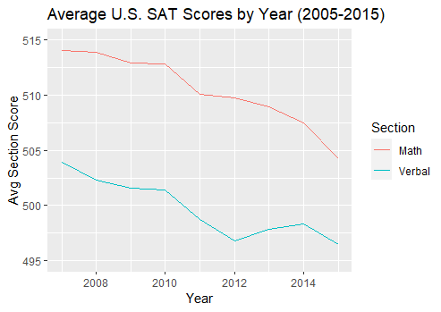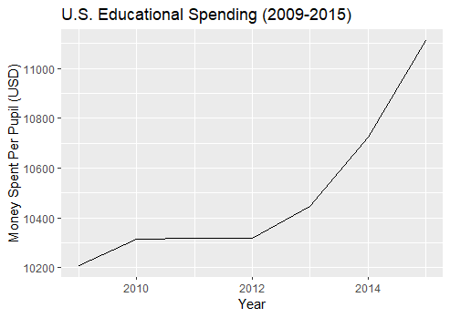

Figure 1

Figure 2

The School Finance Indicators Database publishes an annual data collection of each state’s yearly financial effort towards education. This dataset includes each state’s predicted and actual spending per pupil, teacher-to-student ratios, public school enrollment numbers, and teacher salaries for most years since 1993. The predicted amount of spending is essentially the amount of money a state needs to spend per pupil to achieve the national average in test scores. Some of these variables, such as spending and teacher-to-student ratios, are further divided into poverty district quintiles, giving us a more detailed look into how states allocate their education funds. I was able to merge this dataset with one from the National Center for Education Statistics that measures the average SAT scores from each year in each state from 2005 to 2015. Average scores and the total number of test takers are also calculated based on a variety of factors, such as income bracket, GPA, and gender.

Methodology

Despite my initial intention to compare test scores and educational spending by income bracket, I quickly found that the two datasets were not compatible in that regard. The NCES dataset grouped its income brackets into clean intervals of $20,000, while the SFID dataset used quintiles whose ranges presumably varied from state to state and year to year. Because of this discrepancy, I was unfortunately limited to viewing statewide data that did not necessarily account for states with high or low poverty rates, at least when comparing spending to test scores. The spending data is also unavailable in Hawaii as well as before the year 2009, meaning that I had to further filter out some of the data. In the end, I was left with data from the remaining 49 states, plus the District of Columbia, over the course of seven years. This totaled to 350 observations, which I felt was still sufficient.

After merging the two datasets, I added a few variables not initially included in the dataset that would enhance my analysis. I calculated the average total SAT score by adding the average math and verbal sections, and I also computed the percentage of enrolled students that come from the highest poverty districts, which will be referred to as Q1 districts. Although looking at each income bracket’s data is impossible due to the issue discussed earlier, I decided to include some of the Q1 data in my analysis. Since students who are in the lowest poverty districts and the highest income bracket (Q5) will have sufficient resources regardless of what part of the country they are from, I wanted to see how each state allocated funds to Q1 students in particular. The last group of calculated variables is adjusting the spending data for inflation. Between the years of 2009 and 2015, the U.S. dollar had an average inflation rate of 1.67% per year. I used an exponential function to account for this, and it ended up having a large effect on the results of this project.

From there, I began to create my models and visualizations. By separating the NCES data into separate data frames for each income bracket and binding the rows, I was able to compare the average SAT scores of the different income brackets using the boxplots in Figure 3. Unsurprisingly, the scores increased for the students in the higher income brackets, and it was interesting to see that the variance of the score distribution would shrink for the higher brackets.

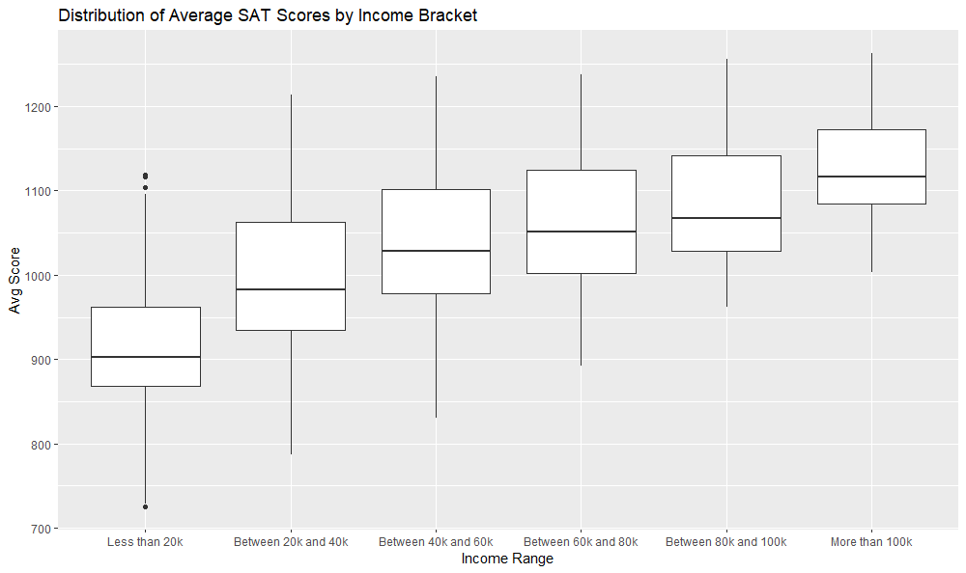

Figure 3

Then, I ran a time-series analysis on each state’s average SAT score between 2007 and 2015. A simple linear regression model was used to calculate the slope of the year-to-year difference of each state’s average SAT scores. I also performed this same analysis on the actual spending data, both with and without adjusting for inflation. Both the average SAT score and the actual spending after adjusting for inflation were then compared to one another, and I calculated the correlation between the two variables for each state. It is better to calculate slopes when doing time series analysis since we are measuring the average year-to-year difference, while correlation is the better metric at measuring the relationship between the two non-time variables.

Results

Although my initial findings showed a steady decrease in SAT scores across the country from 2007 to 2015, I wanted to see if there were any states or groups of states that had skewed the aggregate data. The SFID dataset designates each state into one of four regions: Northeast, South, Midwest, and West. When looking at the average SAT scores for each region over the years, I found that the Midwest greatly outperformed the other regions by about 50 points, as seen in Figure 4. The year 2010 in particular was a serious outlier, even among the higher scores in the Midwest. When looking at contributing factors, none seemed to have a bigger effect than

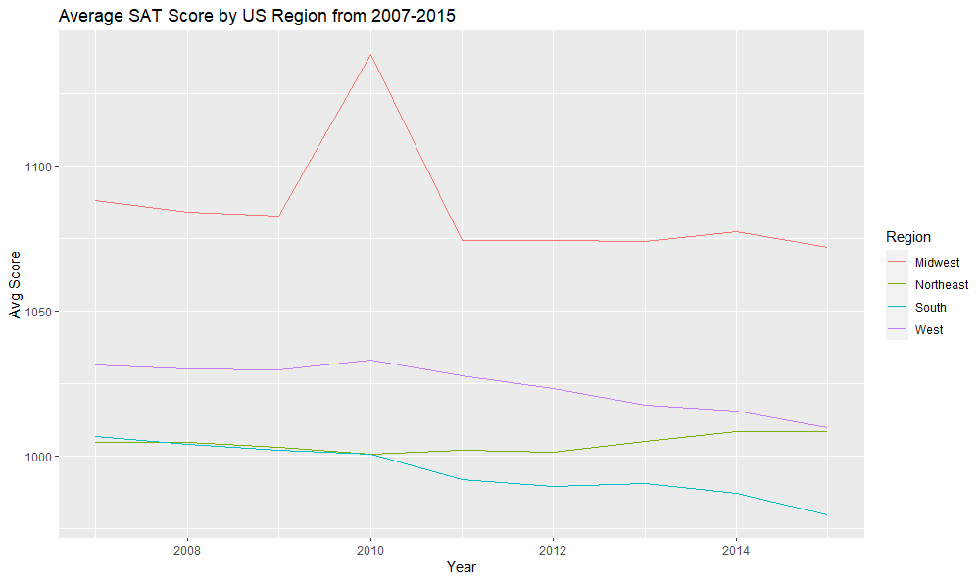

Figure 4

the sample size, or the number of students who took the SAT that year. Figure 5 shows us that the Midwest has far and away the smallest student population out of all regions, and it was particularly small in 2010. In fact, the correlation coefficient between the total number of test takers and the average SAT score when grouping the data by region was a whopping -0.9583586.

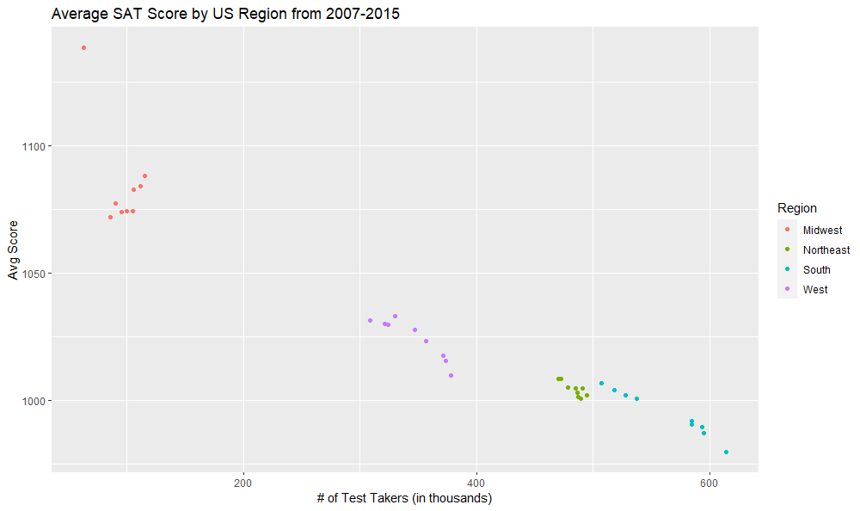

Figure 5

Meanwhile, it was the state-by-state analysis of comparing actual spending to average test scores that provided the most insight for this project. When looking at each state’s year-to-year difference in average SAT scores in Figure 6, I found that about half of the states, 26 of them to be exact, actually experienced an increase in SAT scores, as shown by their positive slopes. In terms of outliers, none were bigger than Idaho’s sudden and inexplicable drop in test

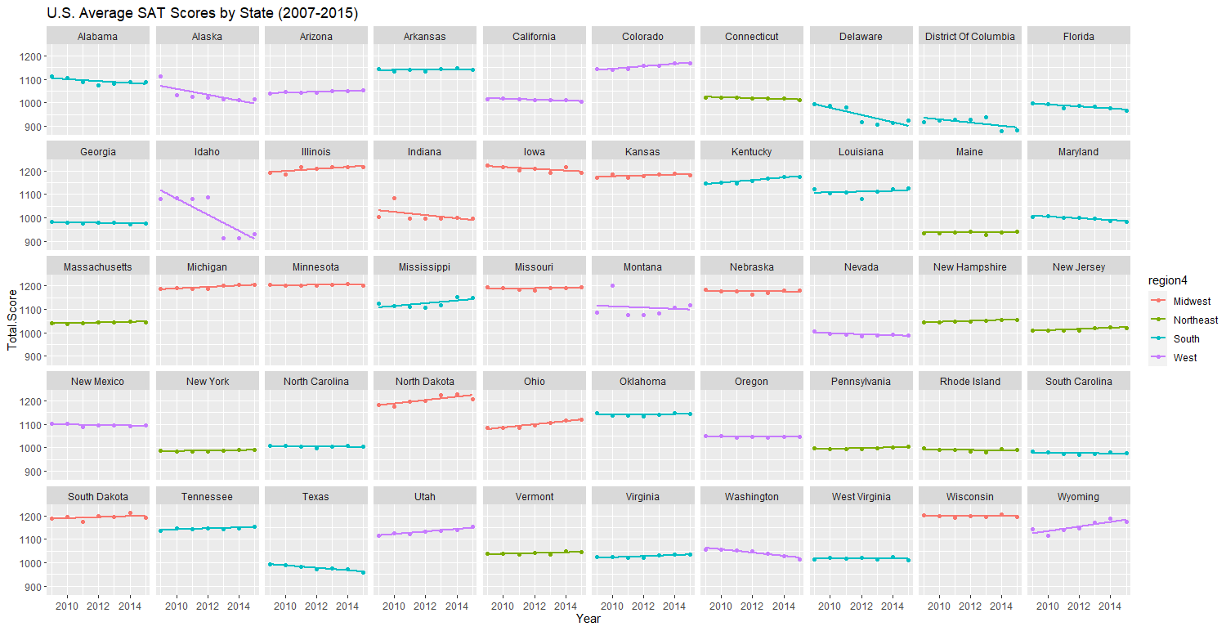

Figure 6

scores in 2013. Because of these, Idaho’s average year-to-year difference of -34.5 points per year is nearly triple that of Delaware, which possesses the next lowest slope.

On the other hand, the analysis of each state’s year-to-year educational spending gave me results that were in line with what I was initially expecting, at least at first. There were only five states (Arizona, Idaho, Georgia, Wisconsin, and Florida) that had a negative year-to-year difference in educational spending. When incorporating inflation into this model, I expected little to no change for the slopes. However, I was shocked to find that the number of states with a positive slope drastically decreased. When accounting for inflation, only 15 states plus DC still saw an increase in spending, as seen in Figure 7. It was also interesting to see that many of the states that still had positive slopes after adjusting for inflation are in the Northeast region.

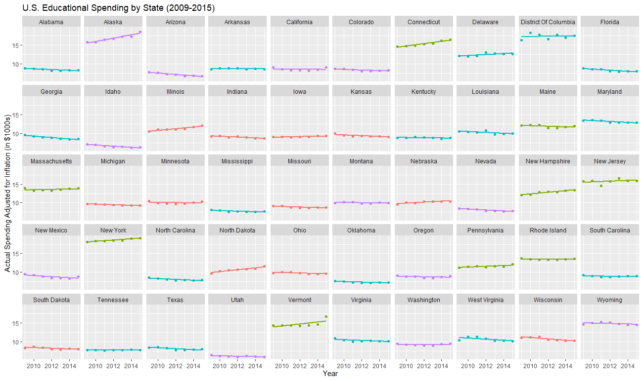

Figure 7

Given that the average year-to-year difference in SAT scores for each state is a mix of positive and negative values while the average difference in educational spending is mostly negative after accounting for inflation, I decided to plot the two variables against one another for each state to see how they are correlated. As a result, Figure 8 is not as visually appealing as the previous plots, but that is due to each state’s unique consistency between both average SAT scores and actual spending per pupil. When measuring the correlation of these two variables for each state, I found a large variation of both positive and negative coefficients. There were five states, those being Alabama (0.9551), South Carolina (0.8705), Maryland (0.8342), Nevada (0.8189), and New Hampshire (0.8068), with a strong positive correlation coefficient between educational spending and average SAT scores. Conversely, I was surprised to find that there were five other states, those being Delaware (-0.9441), Connecticut (-0.9232), Arizona (-0.8344), Michigan (-0.7989), and Ohio (-0.7775), with a strong negative correlation coefficient. This means that these states seem to have worse SAT scores as the amount of spending per pupil increases.

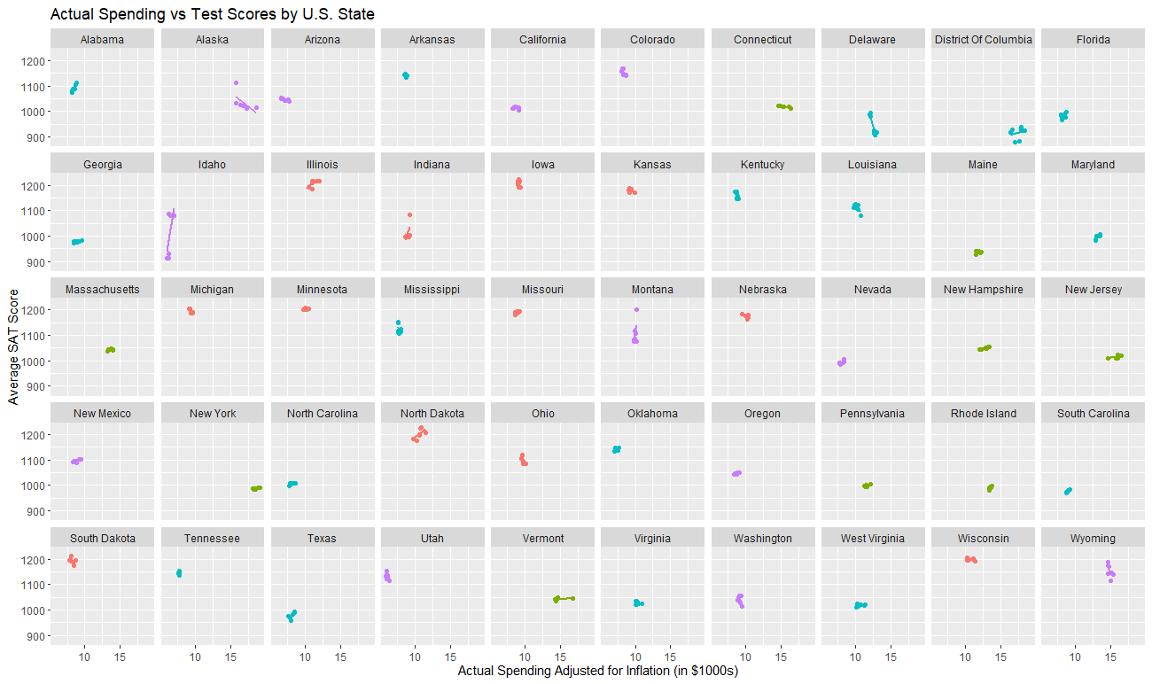

Figure 8

Lastly, I wanted to see what these ten states had in common in order to deduce any factors that led to these strong correlations. I created a clustered heatmap that compared the ten states mentioned above to several aggregate variables, including the average SAT score, total number of test takers, both the predicted and actual spending per pupil with inflation, and the average income statewide. I also looked at the two spending variables both statewide and in Q1 districts. One of the biggest takeaways from this heatmap (Figure 9) was the inverse correlation between student enrollment and actual spending. This phenomenon applies both statewide and in Q1 districts, and is an outcome that I was not expecting at all.

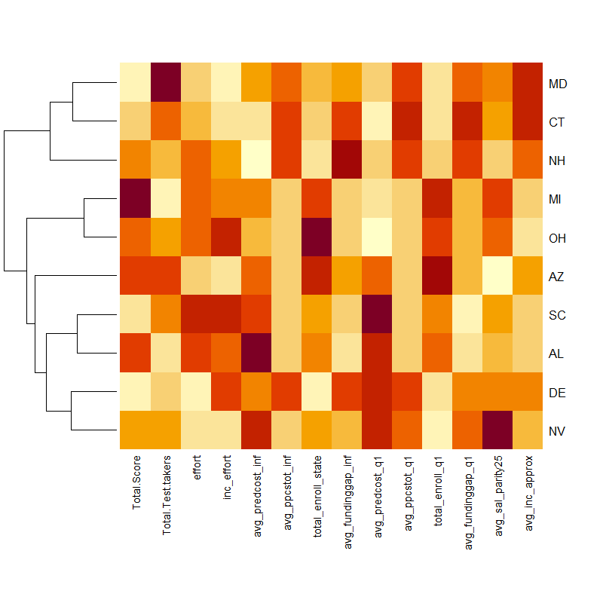

Figure 9

Conclusion

All in all, I was unable to find a definitive answer as to why average SAT scores in the United States have decreased between the years of 2007 and 2015. The incomplete nature of the SFID dataset did not help matters, as I would have liked to delve deeper into specific income brackets to find any trends among the states with negative correlations between actual spending and SAT scores. Even though many of the models that I created could not answer the initial question, I did find that the apparent increase in educational spending, as shown in Figure 2, is mostly a mirage. The numerical value that states are spending on each student is increasing, but due to inflation, the monetary value of this spending is actually decreasing for most states. However, simply raising educational spending so that it is still increasing after adjusting for inflation will not necessarily fix the test score issue, as evidenced by negatively correlated states such as Delaware, Connecticut, and Arizona.

However, if most states truly are decreasing the amount of educational spending per pupil with respect to inflation, then it begs the question why this phenomenon has gone mostly unnoticed. My belief comes from one of the takeaways from the heatmap, which is that student enrollment and educational spending in those ten states are inversely correlated. It is important to keep in mind that the educational spending variable is measured per pupil, which removes any biases towards states with larger populations, such as California and Texas. Many states might not be adjusting to the growing U.S. population when allocating educational funds, which may lead to less funding to spend per student, even if the total funding appears to be increasing.

Overall, the steady decline of SAT scores across the United States should not be as concerning as it may seem. Over the past five years, many colleges and universities across the country have begun to understand that a single, two-hour aptitude test should not completely define a student’s intelligence. They have opted for test-optional policies where an SAT score is not required when applying. These institutions are focusing more on the other ways that applicants can demonstrate their intelligence, such as writing samples, school curriculums, and more. Some people simply are not good test takers. Even though it would be ideal for the average SAT score to be improving, these new policies that colleges are introducing will give more students the opportunity to further their education, even if SAT scores are decreasing.